Data Structures (ETCCDS202)
Unit–1 Assignment: Foundations & Algorithmic Analysis



NAME - RAKSHIT PAL
CLASS – B.TECH CSE(ROBOTICS & AI)
SUBMITED TO – AARTI MA’AM
SUBMITED BY - RAKSHIT PAL
ROLL NO - 2501630004

Part A: Stack ADT (ADT + Operations)
Goal: Understand ADT concept and basic operations.
1. Implement a StackADT class with these operations:
• push(x)
• pop()
• peek()
• is empty()
• size()
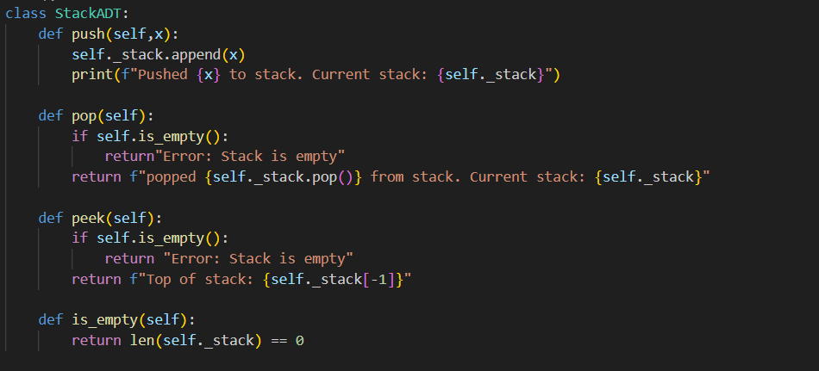
2. Write 3–5 lines in the report:
• What is an ADT?
An Abstract Data Type (ADT) is a logical description of a data structure that specifies what operations can be performed (like push or pop) but not how they are implemented internally.
• Why stack operations are usually O(1) (constant time)?
Stack operations like push and pop are O(1) because they only involve adding or removing an element from the end of the list, which does not require shifting other elements.

Part B: Factorial & Fibonacci (Recursion + Complexity)
Goal: Write recursive solutions and analyze efficiency.
1. Factorial (Recursive)
Write factorial(n) using recursion:
• Handle input n ≥ 0 only
• Use a correct base case (example: 0! = 1)
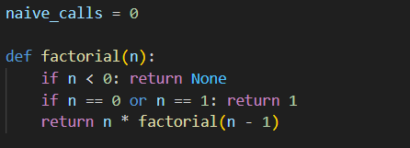
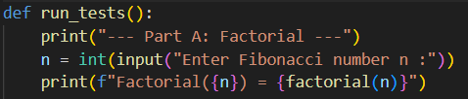
OUTPUT -
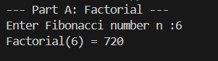

2. Fibonacci (Two Versions)
Write:
• fib naive(n): simple recursive Fibonacci
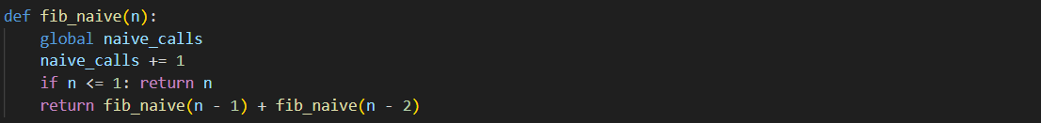
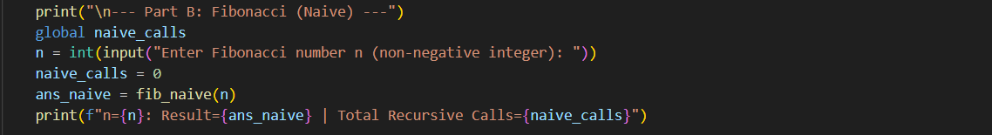
OUTPUT -
Part C: Tower of Hanoi (Recursion + Trace)
Goal: Understand recursion deeply using a classic problem
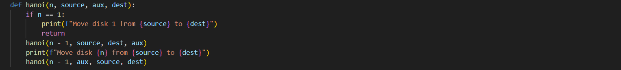
OUTPUT –
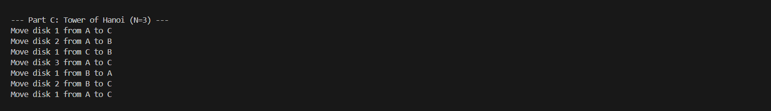
Part D: Recursive Binary Search (Divide & Conquer + Recurrence)
Goal: Learn Divide & Conquer and recurrence reasoning.
1. Implement recursive binary search:
binary search (arr, key, low, high)
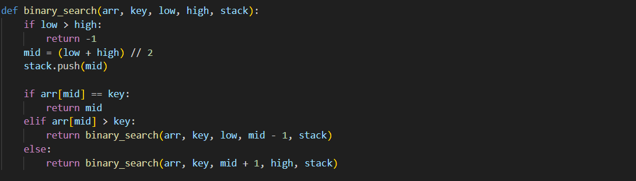
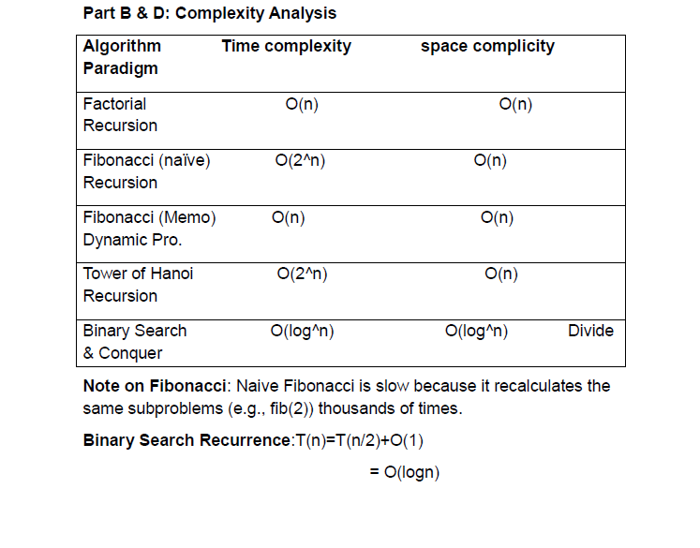
Part E: Short Paradigm Reflection (1–1.5 pages in report)
Divide: The algorithm "divides" the problem into smaller subproblems by finding the middle element of the current array. It compares the search key to this middle element.
Conquer: Based on the comparison, the algorithm "conquers" the problem by narrowing the search to only one half of the array.
1. If the key is smaller than the middle, the entire right half is discarded.
2. If the key is larger, the entire left half is discarded
3. Recurrence and Complexity
4. The efficiency of this approach is represented by the recurrence relation T(n) = T(n/2) + O(1) This means each step reduces the problem size by half (n/2) and takes constant time (O(1)) to perform the middle comparison.

Case Analysis:
Best Case: O(1) — The key is found at the very first middle index.
Average/Worst Case: O(log n) — The algorithm must continue dividing the array until only one element remains

Example: Searching for a Word in a Physical Dictionary Instead of reading every single page from the beginning (Linear Search), you open the dictionary to the middle. You check if your word comes before or after that page. You "divide" the book into two halves, "conquer" the correct half by ignoring the other, and repeat the process until you find the word. This is exactly how your Recursive Binary Search functions

GITHUB Link - https://github.com/palrakshit7914-hub/DSAcllg-Assignment-/upload

